COLT ANALYTICS PLATFORM
Low Level Design
CONFIDENTIAL


Document Information

Version History
Version | Date | Description
1.0 | 26/11/2018 | First version prepared by SAP

Document Author
Name | Role
Ashish Aitiwadekar (SAP) | SAP Solution Architect

Contributors
Name | Role
Oleg Filippov (SAP) | SAP Technical Architect

Approvers
Name | Role | Evidence Link | Date of Approval
Ian Roberts(SAP) | Principal Program Manager
Bhupendra Bahadur Singh (SAP) | Project Manager

For Distribution
Name | Role | Version

 | List all approvers for the document, and insert a link to the evidence of approval (Ctrl+K) for audit.

Table of ContentS
1 Document Information 2
1.1 Version History 2
1.2 Document Author 2
1.3 Contributors 2
1.4 Approvers 2
1.5 For Distribution 2
2 References 5
2.1 Documents 5
2.2 SAP Notes 5
2.3 Glossary of Terms 6
3 Introduction 7
3.1 Project Summary 7
3.2 Scope 7
4 Executive summary – TO BE Updated 8
5 Solution Architecture 9
5.1 Subject Areas in scope of BI Analytics: 9
6 Technical Solution “As-Is” 10
7 To-Be approach 13
7.1 Mapping of Old design to new design 13
7.2 Proposed Target Architecture 14
7.2.1 Phase 1- Minimal Disruptive approach - Transitional stage 14
7.2.2 Overview of the Development Architecture 15
7.2.3 Development tools 16
7.2.4 Development Process Comparison 18
7.2.5 MTA Project 19
7.2.6 Database Module Principles 20
7.2.7 HDI Container 21
7.2.8 Database Module Folder Structure 22
7.2.9 Naming conventions 23
7.2.10 Guidelines 24
7.2.11 Projects in Web Ide 25
8 DEVELOPMENT ACTIVITIES 27
8.1.1 SQL DW ETL Design 28
8.1.2 DB creation 28
8.1.3 Virtualization - Calculation Views 34
8.1.4 Persistency Scenarios 37
8.1.1 Remote sources 38
8.1.2 Reporting 39
9 Application Lifecycle Management 40
10 Security 43
11 Testing 45
12 Currently out of scope but should be considered for Phase 2. 46
13 Appendix – 47
14 References – To be updated 48
Table of figures

Figure 1. As-Is High Level Architecture 9
Figure 2. As-Is L1 Solution Diagram (Subject areas) 10
Figure 3. As-Is L1 Solution Diagram (non-Subject areas) 11

References

Documents
Document | Last Update | Document Version | Author
BI_Solution_Architecture_Plan_V0.1.docx | 11-07-18 | 0.1 | Colt
Netezza_DB_Information.xlsx | 19-07-18 | NA | Colt
Feed_Details_Inbound_Outbound.xlsx | 30-07-18 | NA | Colt
2018_09_17_Entity_Analysis.xlsx | 17-09-2018 | NA | Colt
Netezza_DB_Details_V3.4 | 07.12.2018 | 3.1 | Colt
Netezza_Application_DB_v1.3 | 07.12.2018 | NA | Colt

SAP Notes
ID | Note
1788665 | SAP HANA Support for virtualized / partitioned (multi-tenant) environments
2465027 | Deprecation of SAP HANA extended application services, classic model and SAP HANA Repository
2555629 | SAP HANA 2.0 Dynamic Tiering – Hypervisor and Cloud Support

Glossary of Terms
ID | Description
SDI | Smart Data Integration
SDA | Smart Data Access
DP | Data Provisioning
ODP | Operational Data Provisioning
DWH, DW | Data Warehouse
DT | Dynamic Tiering
ALM | Application Lifecycle Manager
DWF, SAP HDW | Data Warehouse
NDSO | Native Datastore Object
HDI | HANA Deployment Infrastructure

Introduction

Project Summary
Colt are considering migrating from IBM Netezza based to SAP HANA based Business Intelligence solution
The purpose of this document is to provide a detailed view of the design for the Phase 1 of the project.
Phase 1 is primarily a lift and Shift activities with optimizations performed where it is relevant. Due to the nature of the work involved in Phase 1 system generated documentation for HANA models will be created for simple views.

Scope
The scope of the document covers high level design and decision rationale for the following areas:
- Data Migration and modeling approaches
- Integration / Data Sources
- Application Lifecycle Management
- High Level security design approach
- High Level Testing approach

Executive summary – TO BE Updated

Solution Architecture
The aim of Phase 1 is to achieve continued Reporting and Analytics on the various source data transformed and Loaded to HANA database. This will be achieved by replicating the Netezza structures onto HANA and IBM Datastage will be used to provision the data to HANA for Reporting requirements and from HANA for Outbound interface requirements.
Data Migration will be performed by IBM Data stage for this phase in addition SDI will be evaluated for Data migration activities. SDI will also be used for scenarios to load data into Native Datastore objects.

Subject Areas in scope of BI Analytics:
The following subject areas would be introduced to the solution landscape as part of this transformation.
- Accounting (Revenue Data)
- Campaigns
- Corporate Data
- Inventory
- Invoicing
- Involve Party – Master Data
- Location
- Products
- Services assurance
- Service usage
- Service orders

Technical Solution “As-Is”
At a high level the current BI architecture is the following:
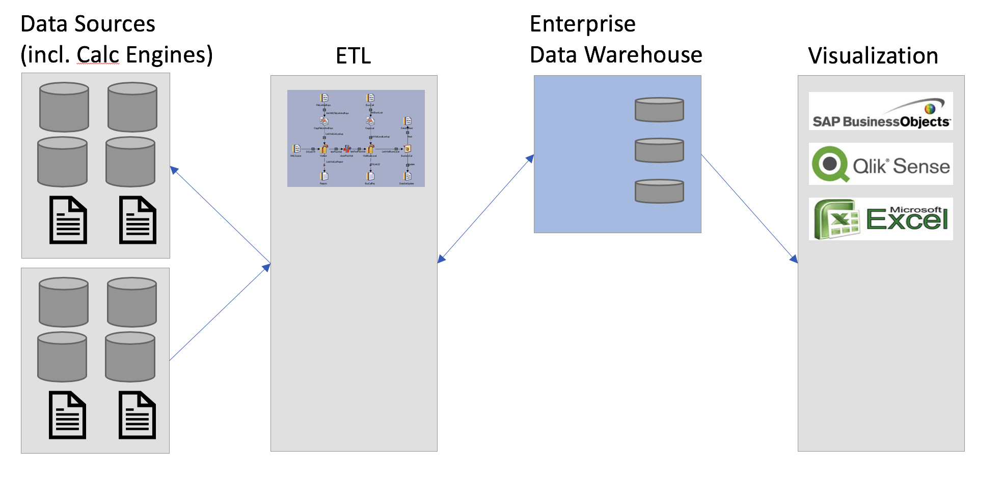
Figure 1. As-Is High Level Architecture
- IBM InfoSphere DataStage is used as ETL tool for inbound / outbound interfaces
- There are 41 source interfaces: (27 inbound / 14 outbound). Different Sources like Database (Oracle, Sql-server etc.), Files (CSV), Web Services (REST Based API, SOAP Based API) – more details can be found in Feed_Details_Inbound_Outbound.xlsx spreadsheet)
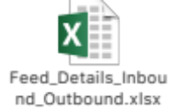
- IBM Netezza is used as Enterprise Data Warehouse
- Two calculation (Xtrac – Oracle based and IRT – MS SQL Server based) engines are used to capture data from IBM Netezza (via ETL layer); the data is transformed and enriched as part of the calculation engine functionality; the transformed data is fed back to IBM Netezza for reporting. In addition, more reporting is done directly from calculation engine datasets
- No full data sets are replicated from the relevant data sources; only selected sets, supported by delta enabled processes, necessary for reporting are loaded into Netezza Data Warehouse.
- Above data captured in L1 dataset
- Further L2 / L3 dataset created wherever required
- Typically, data load is performed out of working hours daily
- Snapshot creation jobs typically run monthly
- Business Objects / Qlik / MS Excel are used for visualization
- Power analytics users have direct access to Netezza for data discovery
- Colt BI landscape comprise of three tiers – Development, Test and Production
- High Availability is provided via IBM Netezza blade architecture. No Disaster Recovery system is currently available.
At present data is replicated from to a multitude of data sources and transformed / enriched based on the Telco data model where data is captured in eight different subject area databases.

Application databases are created for reporting purpose and contain only logical views; segregation into separate Application databases provides additional security.
The following diagram represents L1 data architecture for Subject areas of the current solution (source - BI_Solution_Architecture_Plan_V0.1.docx):
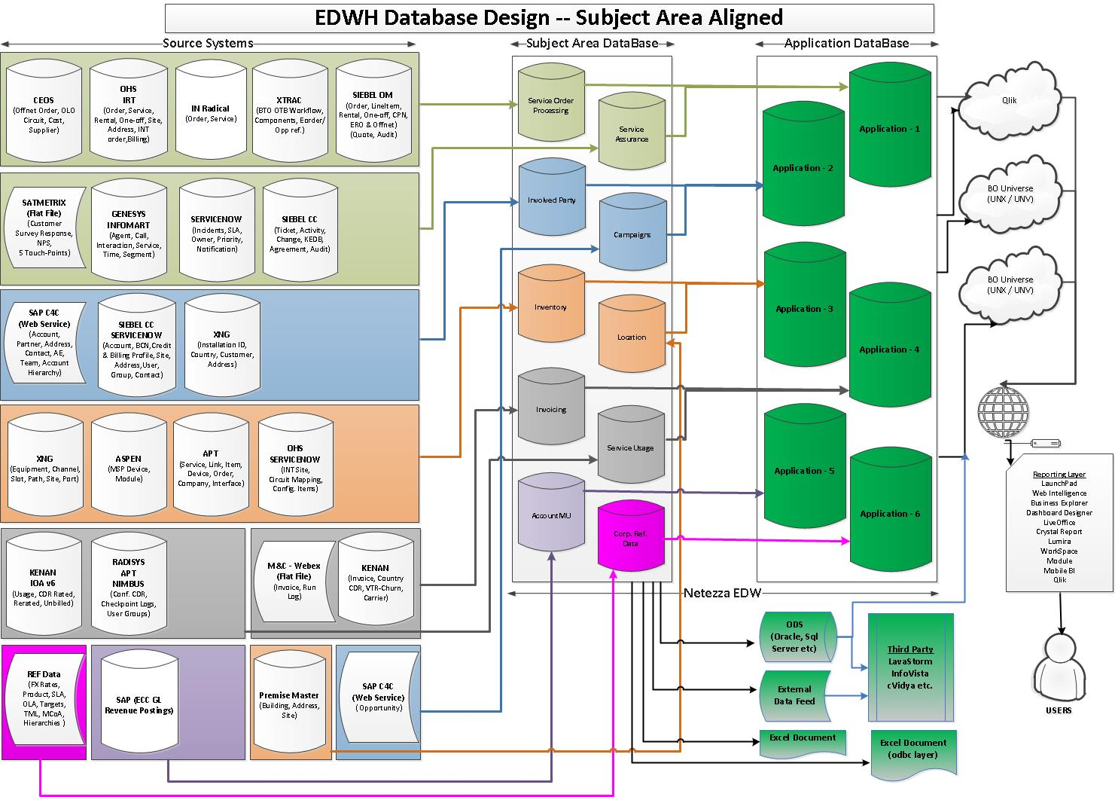
Figure 2. As-Is L1 Solution Diagram (Subject areas)
In addition to subject area databases, several non-subject area databases are created. These are used to store data where volumes are high (like billing).

The following diagram represents L1 data architecture for non-Subject areas of the current solution (source - BI_Solution_Architecture_Plan_V0.1.docx):
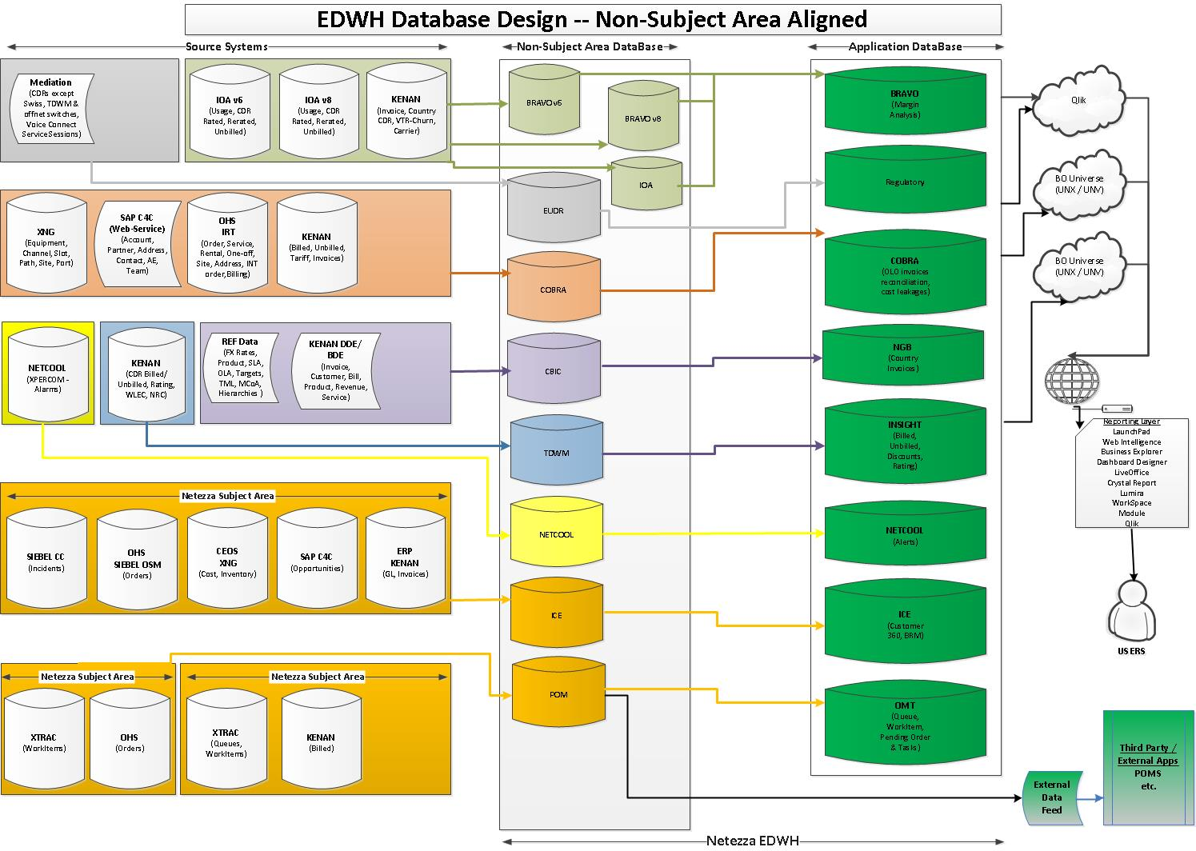
Figure 3. As-Is L1 Solution Diagram (non-Subject areas)
More details on current data model available from the referenced BI_Solution_Architecture_Plan_V0.1.docx document.
The data (including historical data) is currently staged in Netezza database.
All reporting is done against Netezza; no logical views connected directly to the sources are used to avoid impact on the source systems.
Authentication into the Data Warehouse is done via userid / password; authorizations are managed at Business Objects and Netezza (using built hierarchies) levels.

To-Be approach

Although Phase 1 is planned to be a Lift and Shift project some changes must be performed to ensure a well maintainable solution is in place. This change includes reducing the overall Subject/ Non-Subject area.

To achieve this the decision was taken to merge Subject and Non-Subject areas which are Logically tied together. The Same logic is applied to reduce the Application Database to 1, objects within this layer will be used for Cross application reporting scenarios.

This design will ensure reduced operational effort and help in robust Security model as well help in agile type of development cycle with reduced dependency.

Mapping of Old design to new design

Sub Area Indicator | DATABASE | Project | Containers | Folders
Subject Area | ACCOUNTMUPROD1 | EDWP_FINANCIALS | EDWC_ACCOUNTMU
Non-Subject Area | APPCVOIPSTATSPROD1 | EDWP_REGULATORY | EDWC_APPCVOIP
Non-Subject Area | BRAVOV8PROD1 | EDWP_BRAVO | EDWC_BRAVO
Subject Area | CAMPAIGNSPROD1 | EDWP_CUSTOMER | EDWC_CAMPAIGNS
Non-Subject Area | CBIC_PROD1 | EDWP_BILLING | EDWC_BILLING | EDWF_CBIC
Non-Subject Area | COBRAPROD1 | EDWP_BILLING | EDWC_BILLING | EDWF_COBRA
Subject Area | CORPREFDATPROD1 | EDWP_REFDATA | EDWC_CORPREFDATA
Non-Subject Area | EUDRPROD1 | EDWP_REGULATORY | EDWC_REGULATORY
Subject Area | INVENTORYPROD1 | EDWP_INFRASTRUCTURE | EDWC_INVENTORY | EDWF_INVENTORY
Subject Area | INVOICINGPROD1 | EDWP_BILLING | EDWC_INVOICING
Subject Area | INVOLPARTYPROD1 | EDWP_CUSTOMER | EDWC_INVOLPARTY
Non-Subject Area | IOAPROD1 | EDWP_BILLING | EDWC_BILLING | EDWF_IOA
Subject Area | LOCATIONPROD1 | EDWP_INFRASTRUCTURE | EDWC_LOCATION
Non-Subject Area | ODSICEPROD1 | EDWP_CUSTOMER | EDWC_ODSICE
Non-Subject Area | ODSKENANPROD1 | EDWP_BILLING | EDWC_BILLING | EDWF_KENAN
Non-Subject Area | ODSNETCOOLPROD1 | EDWP_INFRASTRUCTURE | EDWC_INVENTORY | EDWF_ODSNET
Subject Area | PRODUCTPROD1 | EDWP_REFDATA | EDWC_PRODUCT
Subject Area | SERVASRPROD1 | EDWP_SER_ASSU | EDWC_SERVASR
Subject rea | SERVIUSAGEPROD1 | EDWP_BILLING | EDWC_SERVIUSAGE
Subject Area | SERVORDPROPROD1 | EDWP_SER_DEL | EDWC_SERVORD
Non-Subject Area | TDWMPROD1 | EDWP_BILLING | EDWC_BILLING | EDWF_TDWM

Proposed Target Architecture
Following sections provide the technical view of the To Be Architecture and required components.

Phase 1- Minimal Disruptive approach - Transitional stage
At this stage the proposal is to keep existing InfoSphere DataStage as ETL and to install SAP HANA database to replace IBM Netezza database in the productive environment, in the development environment parallel loads will be performed
Based on the discussions carried out during the workshop conducted on 18/19th October in Bengaluru and followed by calls the following Points are considered as critical for deriving the final design for the Analytics project.
- Existing Reporting Use cases and continuity of existing tools with little to no disruption
- Reuse of existing ETL functionality
- DB Artifacts and Optimizations options
- Housekeeping Activity to eliminate unwanted Artefacts in the new environment

Considering the critical factors mentioned above the following Data Warehouse Design is proposed.
Below is the Graphical representation of the Proposed Architecture for the Phase 1

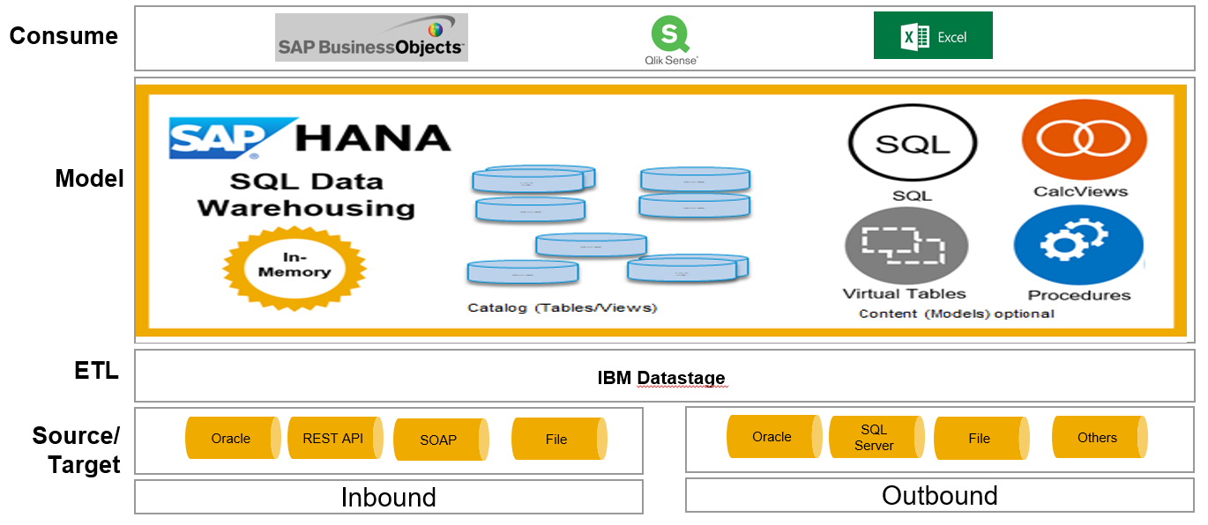

Overview of the Development Architecture
As COLT uses HANA 2.0 SAP recommend following XSA Architecture where applicable. XSA is the new Architecture which currently coexists with XSC Architecture but will be the Architecture option supported in the long term.
Usage of XSA leads to additional Administration and Security configurations which will be partly defined in the later sections but will be detailed out in the Admin and Security document.
Due to the requirement to use Dynamic Tiering for the staging data XSC will be used on this project as the DLM for Dynamic Tiering is supported on XSC.
Although the intention is to leverage the use of existing components, it is highly recommended to use the available components when using new features. Example – SDI to load data in NDSO.

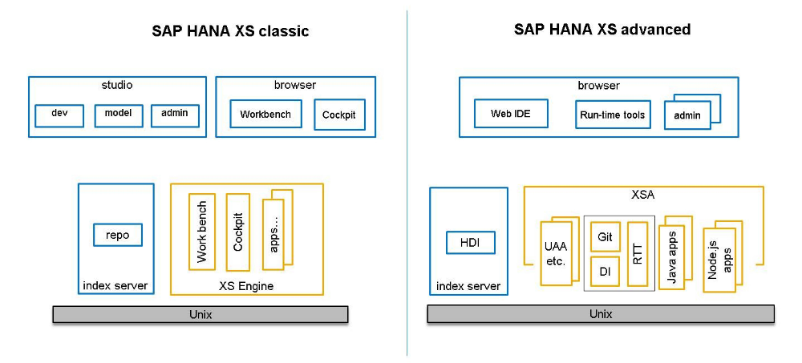

Development tools

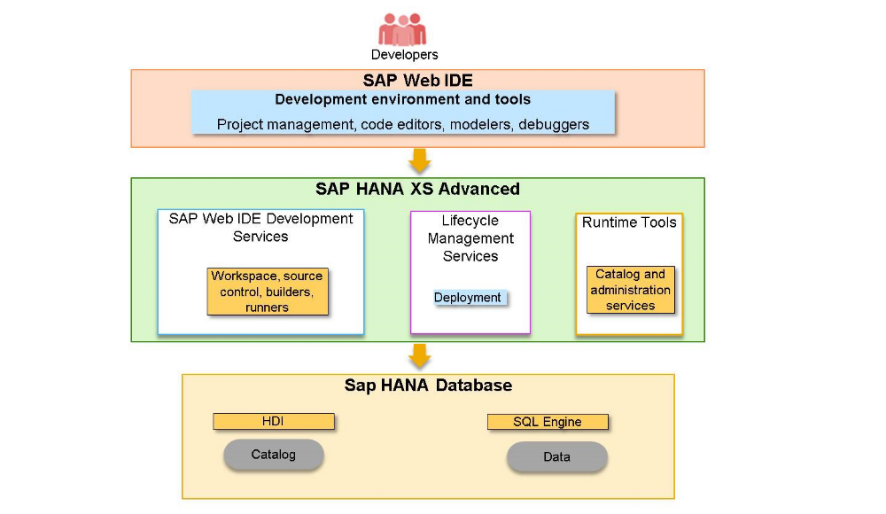
SAP Web IDE for SAP HANA is the successor to SAP HANA web development workbench and the development perspectives of SAP HANA studio.
It offers
  - Development of SAP HANA content and models
  - UI development with SAPUI5
  - Development of polyglot applications
  - Node.js, Java or XSJS business code
  - Git integration
It is
  - Browser based
  - Installed as SAP HANA XSA application

Web IDE in combination with the toolset around will be used the project to model, develop and deploy the SAP HANA SQL DW application due to the following factors,
- Use SAP Web IDE for SAP HANA in combination with the toolset around.
- SAP Web IDE is the new standard IDE offering, both for on premise and cloud, serving all programming model layers offered.
- It provides Integration with Git as the de facto versioning system standard and – by running in XSA itself – can build and run your applications using the deploy service to instantiate or update the respective services/containers of your application.
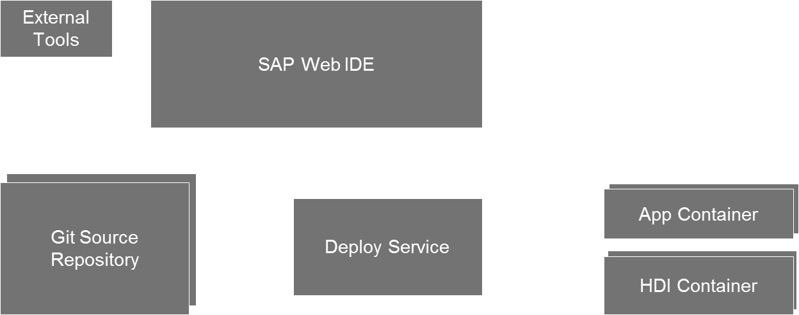

SAP Web IDE for SAP HANA is designed to guide you through the development process required to deploy multi-target applications.

This process includes the following high-level steps:
- Set up an application project.
- Develop your application modules.
- For example, for your data model, your application business logic, and your client user interface.
- Build your application modules.
- Run and debug your application modules.
- Package the modules into a multi-target application.
- Deploy the application to SAP HANA XS advanced.

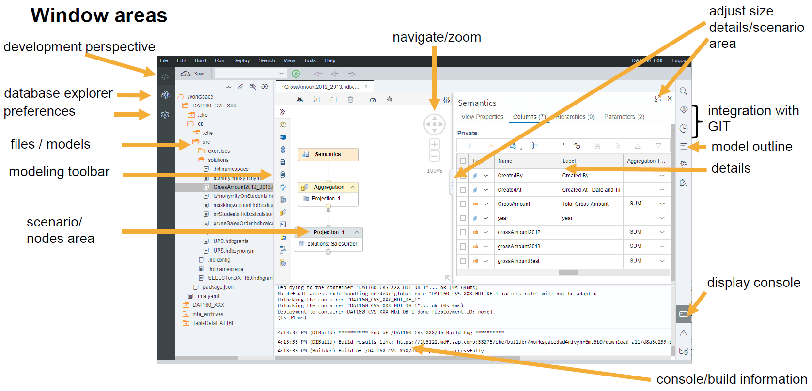

Development Process Comparison
HANA XS Classic | SAP HANA XS Advanced
SAP HANA repository contains design-time objects. | External GIT repository contains design-time objects.
Objects are organized in repository packages. | Objects are organized in MTA projects.
Database runtime objects are created upon activation of design-time objects. | Projects have to be built by the XSA infra-structure.
Objects can be activated individually. | Database runtime objects are created upon development of the built HDI container.
User_SYS_REPO owns all runtime objects | A generated ...#OO user owns the runtime objects for a specific HDI container.

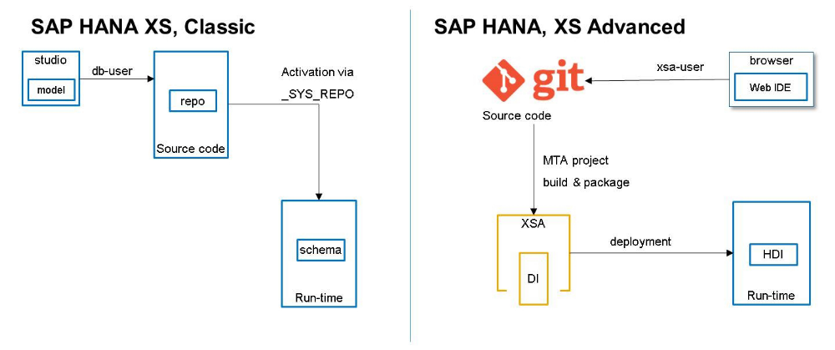
The process works as follows:
- The developer pulls the latest sources from the GIT repository into his Web IDE development workspace.
- The developer makes changes to the code.
- The developer builds a local version of the project, which is done by the development infrastructure.
- To run, test, and debug this version, the developer again uses the development infrastructure.
- The developer commits the changes to the local workspace.
- When the developer is satisfied with the changes, they create the MTAR archive, which contains the built objects.
- From the local workspace, the changes are pushed to the central GIT repository.
- The MTAR archive will be deployed by an administrator in the target system .

MTA Project
- Multi-target applications (MTA) comprise multiple “modules” (software components) that all share a common life cycle for development and deployment.
- The type of module determines the development language and run time environment t will be executed in. Example HTML5 modules are executed in the Web Browser, Node.js and Java modules are executed in the XS application server, SAP HANA DB modules are executed in the SAP HANA Database as shown below.
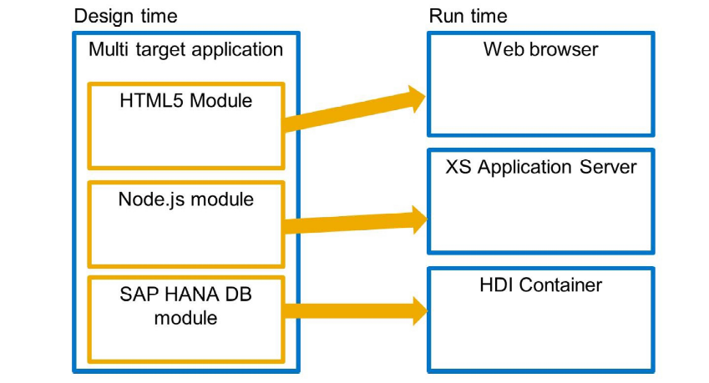
- From an EDW perspective, due to the flexible nature of the logical data warehouse architecture, it would make sense to deploy a single MTA/Project for the underlying data warehouse (Database Module, DWF Module and node.js Module) artefacts at a layer and domain perspective.
- This provides the benefit of organising and segregating development objects along the logical construct of how they would be developed and deployed from a life cycle perspective.
- It also allows for the future scale out of deployment into additional domains that are decoupled from existing deployments (aside from the virtualisation/business representation Layer).
- In the folder structure of the MTA archive, each module has its own folder. For example, an XS advanced MTA could have the following base-level folders:
- web/ -A folder for static Web content and the application router configuration
- java/ - A folder for a Java application
- js/ - A folder for a Node.js application (including XS JavaScript, too)
- db/ -A folder for the SAP HANA database artifacts, for example: tables, views, stored procedures, Calculation Views, and so on...

The HDB module is used to create the database content. During deployment, the HDI container is created on the database and the artefacts are generated inside. The Web IDE supports the creation of several database artefacts and generates default files:

project.json
Contains information on the module. Doesn't need to be changed.

.hdiconfig
Contains the plugin name and version for every supported file suffix.

.hdinamespace
Contains namespace configuration for the HDB module

Database Module Principles
- There is no one-to-one mapping between the file-system structure and the names of the resulting run-time objects.
- The names of run-time objects are determined by naming rules defined in HDI name-space files - .hdinamespace.
- The file-system structure can still be used to derive the run-time name space of an object. However, decoupling design-time file structure and run-time name-space names allows the file-system structure to reflect the organisation of work, and it is easy to relocate design-time resources without changing run-time namespaces.
- Note: If design-time folder names do not contribute to run-time names, issues with limitations on object name length can be avoided. The maximum length of the fully qualified object name (including the namespace) is 127 characters.

HDI Container
- SAP HANA DI is a service layer of the SAP HANA database that simplifies the deployment of SAP HANA database artefacts by providing a declarative approach for defining database objects and ensuring a consistent deployment into the database, based on a transactional all-or-nothing deployment model and implicit dependency management.
An SAP HANA DI container is a database schema
- Database objects are deployed into the schema
- Definitions must be written in a schema-free way
- Database objects are owned by a container-specific technical object owner
- Schema-external objects are referenced via database synonyms (or table links)
- An SAP HANA HDI Container consists of a Design-Time Container (DTC) and a corresponding Run-Time Container (RTC).
- An RTC does not know about the concept of DTCs. As a consequence, the RTC can be identified with a standard database schema without any need for HDI metadata.
- The creation of an RTC results in a new technical database user and a schema with the same name as the one chosen for the name of the RTC itself. Access to RTC content is controlled by database privileges, for example, by granting SELECT or EXECUTE privileges.
- Containers; SAP HANA DI containers allow multiple deployments, sandboxing, etc.
- Focus on deployment; no version control aspects, no lifecycle management aspects
- Database objects only; no JavaScript programs, no OData, no application-layer artefacts

Database Module Folder Structure
Container Structure:

- 00_Staging – Staging tables
- 01_Masking – Objects relevant for masking
- 02_Master Data – DB tables for Master data (Reference data in COLT) Specific to Subject Area
- 03_Transaction Data - DB tables for Transaction Data Specific to Subject Area
- 04_Models – Foundation Views, API views depending on the level
  - Foundation views – Wrapper views 1:1
  - API views – Mainly reporting views
  - Propagation views - If twostep process is required to populate tables or if Business Logic is applied from One Level to other.
- 05_Test – Graphical views connecting Netezza tables remotely union with HANA tables.
- NDSO – Store NDSO Specific to Subject Area

The above structure is a proposed design and will be adjusted during the project phase.

Naming conventions

Object Type | Naming Convention | Options/Comments
Schema/ Container | <APPLICATION>_<SCHEMA NAME> | Example:EDW_PLATFORM, EDWC_BILLING
Virtual Table | VT_<OBJECT>
CDS – Table/DSO | CDS_<OBJECT/FUNCTION NAME>.<CONTEXT TYPE>.<OBJECT> | Note: CDS context info used as object type identifier, i.e. TAB or DSO
Sequences | SEQ_<Object name>
VDM Access | CV_PREFIX_<Object>  Prefix – P- Propagation, F- Foundation A- API | CVO_BR_LIST_INV_NO_NL
Flowgraph | FG_<TYPE>_<INFO>_<Object> | Type:<RT|BT>  Info: <LOAD | CLEAN | LOADINIT | CLEANINIT>
Task Chain | TC_<TYPE>_<Object> | Type: <LOAD | CLEANSE>
Table Functions | TF_<Object/Function name>
Synonyms | <use same prefix for namespace as synonym target>.<TABLE NAME>
Proxy objects | <use same prefix for namespace as proxy target>.proxy.<TABLE NAME>
WEB IDE projects | <Project>_<APPLICATION AREA>_<APPLICATION> | Example: EDWP_APPLICATION

Guidelines
- Create HDI container per Subject, Non-Subject DB plus additional for integration/virtualisation layer
- Use namespace concept to classify database objects
- Create access roles in DB module for all Source DB’s and grant access in DB module for integration/virtualisation layer
- Use virtualisation layer as central point of access for all EDW access for cross application scenarios.

Projects in Web Ide
9 Projects for Persistence, Foundation Calculation views, NDSO’s – Grouped by Business Area
- Each Project (Example EDWP_INFRASTRUCTURE) has one or more than one HDI container / Folder
- Example HDI for EDWC_INVENTORY
- Folder for EDWF_ODSNET
  - EDWP_BRAVO
    - EDWC_BRAVO
  - EDWP_CUSTOMER
    - EDWC_CAMPAIGNS
    - EDWC_INVOLPARTY
    - EDWC_ODSICE
  - EDWP_FINANCIALS
    - EDWC_ACCOUNTMU
  - EDWP_INFRASTRUCTURE
    - EDWC_INVENTORY
      - EDWF_INVENTORY
      - EDWF_ODSNET
    - EDWC_LOCATION
  - EDWP_REFDATA
    - EDWC_CORPREFDATA
    - EDWC_PRODUCT
  - EDWP_REGULATORY
    - EDWC_APPCVOIP
    - EDWC_REGULATORY
  - EDWP_SER_DEL
    - EDWC_SERVORD
  - EDWP_SER_ASSU
    - EDWC_SERVASR
  - EDWP_BILLING
    - EDWC_BILLING
      - EDWF_CBIC
      - EDWF_COBRA
      - EDWF_IOA
      - EDWF_KENAN
      - EDWF_TDWM
    - EDWC_INVOICING
    - EDWC_SERVIUSAGE
  - EDWP_REPORTING
    - EDWC_REPORTING

Project | Container | Folder
EDWP_BRAVO
 | EDWC_BRAVO
EDWP_CUSTOMER
 | EDWC_CAMPAIGNS
 | EDWC_INVOLPARTY
 | EDWC_ODSICE
EDWP_FINANCIALS
 | EDWC_ACCOUNTMU
EDWP_INFRASTRUCTURE
 | EDWC_INVENTORY
 |  | EDWF_INVENTORY
 |  | EDWF_ODSNET
 | EDWC_LOCATION
EDWP_REFDATA
 | EDWC_CORPREFDATA
 | EDWC_PRODUCT
EDWP_REGULATORY
 | EDWC_APPCVOIP
 | EDWC_REGULATORY
EDWP_SER_DEL
 | EDWC_SERVORD
EDWP_SER_ASSU
 | EDWC_SERVASR
EDWP_BILLING
 | EDWC_BILLING
 |  | EDWF_CBIC
 |  | EDWF_COBRA
 |  | EDWF_IOA
 |  | EDWF_KENAN
 |  | EDWF_TDWM
 | EDWC_INVOICING
 | EDWC_SERVIUSAGE
EDWP_REPORTING
 | EDWC_REPORTING

DEVELOPMENT ACTIVITIES
The overall scope of Phase 1 of the project covers the following areas.

- SQL DW ETL Design
- DB Creation
- Virtualisation
- Persistent data models
- Remote sources
- Reporting

Following sections cover the details of the activities involved in each of the area mentioned above.
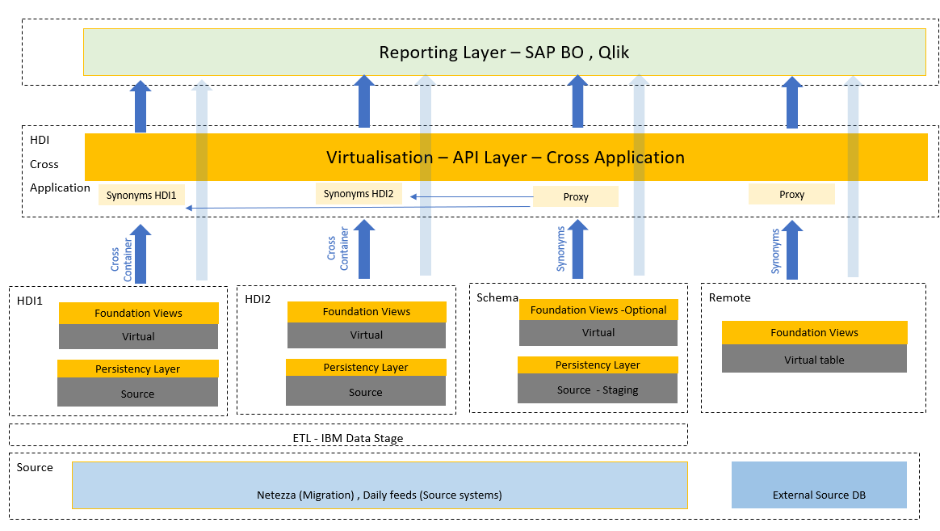

SQL DW ETL Design
- IBM DataStage will continue to function as the ETL tool for phase 1.
- To ensure that IBM DS can function will less disruption, HANA tables will be created with the same table and field names.
- Alignment of datatypes to HANA datatypes will need adjustments to the ETL jobs.
- In case of NDSO’s (Detailed later) recommendation is to use Smart Data Integration Feature(SDI) and DWF features for internal movement within HANA.IBM DS is also supported for loads to NDSO’s.
- Testing for Data type alignment, overall Data and ETL job mapping must be performed, further details are mentioned in the section Testing.
- IBM DS will be used for Daily feeds.
- SDI is being evaluated for Data Migration activities, further discussions / POC is required to estimate the efforts.

DB creation
Database table creation:
A detailed level analysis has been performed for Table Analysis Lead by COLT, EY and supported by SAP.
Part of Analysis phase we have identified various categories which will help in optimization of the DB tables
Details of all tables used for analysis can be found in the DB sheet .
Migration Categorization
Category | Description | Count
 | Total | 6350
A | No Migration | 3145
B | As-Is migration | 1587
C | Migrate As-is with optimized volume | 0
D | Optimized Design - Dynamic Tiering | 1608
E | Optimized Design & Volume - View | 10

- No Migration
The tables identified as not required in HANA may be due to redundant nature or used for testing or used for interim projects.
- As-Is-Migration
Tables in this category are the tables that are required in memory as they will be used for reporting requirements by Qlik or SAP BO reporting.
- Migrate As-is with optimized volume
Tables in this category will be subset of B which will be have partitions or Indexes for performance reasons as well as for limiting the column to reach the threshold of 2 billion records.
- Optimized Design - Dynamic Tiering
Tables in this category are the tables that are required for ETL purposes and 1% of the total tables could be used for Legacy reports as standalone objects.
- Optimized Design & Volume – View
Tables in this category will be modelled as Calculation views where applicable.

Below is the split of the tables by Levels in the existing DB mapped to the migration category.
Total 2885 (excluding snapshot and L3) tables are in scope, below table shows the split of the tables split by modules. Modules are simple grouping to ensure a specific functional area is covered, this will also help develop and test in small and logical packages.

Inventory as of 7th Dec 2018
Priority | Module | L1- B, D | L2 B, D | L3 | Snapshot | Summary | Staging
1 | Sales | 140 | 7 | 1 | 5 | 1 | 146
2 | Billing | 276 | 16 |  |  |  | 371
3 | Service Assurance | 94 | 2 | 1 | 6 | 2 | 139
4 | Service Delivery-Operational Reporting | 314 | 18 | 6 | 3 |  | 364
5 | Service Delivery-Network Inventory | 90 | 14 | 2 |  |  | 64
6 | Sales-Qlik | 1 | 1 |  | 1
7 | Others-REFDATA | 53 |  |  |  |  | 8
8 | Finance-Bravo | 105 | 66 |  |  |  | 272
9 | Regulatory | 71 |  |  |  |  | 5
10 | Service Delivery-COBRA2 | 72 |  |  |  |  | 27
11 | Service Delivery-Others | 33 | 2 |  |  |  | 21
12 | Others | 9
13 | Finance-Others | 41 |  |  |  |  | 1
14 | Finance-Project Accounting & Card GL | 39
 |  | 1338 | 126 | 10 | 15 | 3 | 1418

Architecture overview
First step of the project would be to create the tables in the HANA Database with the same structure as in IBM Netezza. In addition to efficiently utilize the HANA Memory, Dynamic Tiering will be used.
Considering the number of tables that need to be created, SAP has investigated the below options.
Option 1 – Usage of the Designer tools. - Power Designer + Enterprise Architect Designer:
The below approach is two steps,
Step 1 – Usage of Power designer
Power Designer is and SAP designer tool capable of reverse engineering the Database to generate Physical Data Models, the advantage with Power Designer is its capability to reverse engineer Netezza ensuring correct conversions of the datatypes from Netezza to HANA.
Steps include:
- Connectivity to IBM Netezza environment
- Reverse Engineer the DB – Selective DB’s for simplification
- Generate Physical Data Model
- Export Physical data model.

Step 2 – Usage of Enterprise Architect Designer
Enterprise Architect Designer is a recent SAP Designer tool capable of reverse engineering the database to generate physical data models and further create the physical objects in target Database. The advantage of this tool is its compatibility with HANA 2.0 XSA Architecture.
Steps include:
- Connectivity to Target HANA DB
- Import Physical Data Model from Step 1
- Generate Physical data model in the required HDI containers.
- Validate the table structures and the datatypes.

Option 2 – Usage of the Remote source in database explorer to create Virtual table
SAP recommends using the Remote source feature in HANA 2.0 SPS3 to achieve this activity. Additional check is required to ensure the correctness of the target Datatypes
Steps include:
- Connectivity to IBM Netezza
- Create IBM Netezza as remote source
- Create Virtual tables from Database Explorer
- Select tables considering the categorization i.e. Tables required for in-memory should be created using this approach as the other tables will be created for support of Dynamic tiering.
- Assign namespaces- Assign prefix VT_ for Virtual tables.
- Create Design time objects with reference to Virtual tables structure
- Assign the HDI container per definition in section 7.2.13
- Validate tables
- Partitioning criteria and other configurations will be created during design time creation or post design time creation.
Note:
- Primary keys if defined in the source will be replicated in Virtual table structure, this does not appear the use case in COLT.
- Table structure alignment with Netezza structure has been evaluated and conversions are correctly performed using this tool.
- Creation of Design time objects will help avoid issues arising during deployment to further landscapes.

Optimization of the tables:
To enhance the performance of the overall application additional configurations for tables like Indexing and Partitioning will be considered. This will be done at a later part within the first phase,
Other than Partitioning for performance reasons, the same will be required to avoid the 2 billion thresholds for table with high volumes, this will be done once the tables are created. A total of circa 55 tables have been identified to have volumes, this includes all tables including outbound, excluding not required.

Per the information received from COLT below is the summary of the tables split by modules. Individual table list is provided in the Master Excel provided as attachment in the
Priority | Module | Partitioning
1 | Sales
2 | Billing | 13
3 | Service Assurance
4 | Service Delivery-Operational Reporting
5 | Service Delivery-Network Inventory
6 | Sales-Qlik
7 | Others-REFDATA
8 | Finance-Bravo
9 | Regulatory | 40
10 | Service Delivery-COBRA2
11 | Service Delivery-Others
12 | Others
13 | Finance-Others
14 | Finance-Project Accounting & Card GL
 | Total | 53

Dynamic tiering tables
- Staging data has been classified as candidate for Dynamic Tiering.
- Very minimal reporting requirements have been identified for this data.
- The movement of Staging data to Dynamic Tiering will reduce the In-memory footprint
Two types of tables can be created that host part or all their data in the dynamic tiering store:
- 1. Extended table: an extended table is an SAP HANA column table, where the table definition resides in the HANA catalog, but all the data in the table is stored in dynamic tiering.
- 2. Multistore table: a multi-partitioned SAP HANA column table, where at least one partition resides in default storage (SAP HANA memory), and one partition resides in extended storage (dynamic tiering).
Extended and multistore tables are first class database objects – part of the SAP HANA catalog, and able to be used in SQL and calculation views.
Multistore tables will be created to achieve the Dynamic Tiering requirements for Staging information.
Data Lifecycle Manager Tool (DLM)
- DLM is part of Data Warehousing Foundation and will be used to automate the movement of data to the extended table
- DLM allows modelling of migration rules on tables to move less frequently accessed data to alternate storage tiers, such as dynamic tiering
- DT is supported by XSC version of DLM (Data Lifecycle Manager) but can run in XSA environment
For Dynamic Tiering on Public cloud read https://launchpad.support.sap.com/#/notes/0002555629

Priority | Module | DT -  L1, L2 ,Staging
1 | Sales | 146
2 | Billing | 396
3 | Service Assurance | 139
4 | Service Delivery-Operational Reporting | 364
5 | Service Delivery-Network Inventory | 64
6 | Sales-Qlik
7 | Others-REFDATA | 8
8 | Finance-Bravo | 311
9 | Regulatory | 56
10 | Service Delivery-COBRA2 | 27
11 | Service Delivery-Others | 21
12 | Others | 2
13 | Finance-Others | 4
14 | Finance-Project Accounting & Card GL
 | Total | 1538

The tables will be created in the Subject DB containers to which they belong based on the classification sheet like the normal tables. Multistore tables need to be partitioned for DLM.

Virtualization - Calculation Views
It is recommended that all the tables are accessed via the HANA views, no direct access should be allowed.
A HANA view on top of the table provides flexibility, reusability and additional security of data in case of Data masking.
A total of 1519 views will be created of which 1222 will be direct views and 175 will be custom views.
The plan is to create Graphical views where possible this will be valid for direct views (1:1), but custom views (multiple direct views) could need scripting and table functions will be used. The extent of complexity is unknown and further discussions will be conducted for this.
Foundation layers – Prefix – CVF_
Views with 1:1 mapping is referred as Direct views and should be part of the foundation layer.
During analysis it is identified that same table/ view is used in more than one view and a separate object is created this should be avoided where possible.
Foundation views should be created under the subject DB containers, total of 1222 have been identified.
- 21 views are based on control tables – TBC if these are needed.
Example:
MV_INTEGRATED_GL_REVENUE
MV_INTERNAL_CAPEX_POD
MV_SALES_ACCOUNT
API Layer - Prefix – CVA_
- Views with more than one view and cross application table access are referred to as custom view and should be part of the API layer.
- Outbound views should be created under this layer as they are interfaced out or used for reporting.
- API views should be created under Application DB container, total 150 + 10 L3 + 15 Snapshot views have been identified.
- A detailed analysis will be performed to check the feasibility to convert/ simplify the API views , due to the time constraints a decision could be taken to utilize the existing code in Table functions with some minor tweaks.
Example:
MV_EXTERNAL_CAPEX
CB_OHS_CONTRACT_2
OHS_CONTRACT_SITE_ORDER_1
Outbound- CVO_
- Outbound views required for ETL and Reporting will be created in API layer, 122 views have been identified.
- 27 views are based on control tables – TBC if these are needed.
- Confirm the layer these should go in.
Propagation Layer Prefix – CVP_
- Views used in API layers which has logic that can be separately build will be created at this layer.
- Propagation views will be created in API layer.
Table level changes-
- Generated columns will be used where fields from single table is used for logic/ calculation.

Priority | Module | L3 | Snapshot - NDSO | Wrapper Views | Custom Views | Outbound
1 | Sales | 1 | 5 | 147 | 32
2 | Billing |  |  | 267
3 | Service Assurance | 1 | 6 | 96 | 17
4 | Service Delivery-Operational Reporting | 6 | 3 | 316 | 30 | 16
5 | Service Delivery-Network Inventory | 2 |  | 104 | 15
6 | Sales-Qlik |  | 1 | 2 | 5
7 | Others-REFDATA |  |  | 53
8 | Finance-Bravo |  |  | 31 | 10 | 101
9 | Regulatory |  |  | 20 | 1
10 | Service Delivery-COBRA2 |  |  | 72 | 4
11 | Service Delivery-Others |  |  | 30 | 12 | 5
12 | Others |  |  | 7
13 | Finance-Others |  |  | 38 | 27
14 | Finance-Project Accounting & Card GL |  |  | 39 | 13
 | Total | 10 | 15 | 1222 | 166 | 122
 |  |  |  | -21 | -16 | -27

Open points
- Parameter information for direct views and details for the custom view creation is planned during the initial phase of development.
- The proposal is to adhere to the naming conventions while creating HANA views

Cross container Scenarios:
While using the HDI approach, tables within one container cannot be directly accessed from other containers, the access is achieved by usage of synonyms. Two scenarios are possible
- Access between two containers
- Access between XSC and XSA components
Additional CUPS (User provided services) Services must be defined to achieve access to objects in the schema

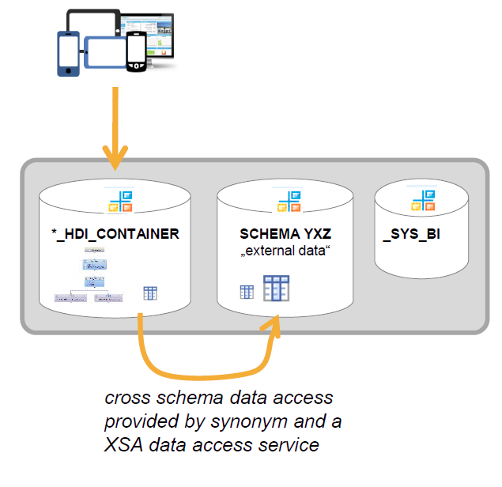
Deployment
Deployments are done into isolated HDI containers
Runtime objects of Calculation Views reside in HDI-container (“schema”)
Access
refer: synonyms to address objects outside of container
provide: services for providing access to target objects of synonyms (services are referenced in mta.yamlfile)
grant: .hdbgrants to authorize technical users for modeling; authorization are assigned by services that are referenced in .hdbgrantsfile
In addition to the creation of Synonyms additional security must be considered.

Persistency Scenarios
NDSO
For Snapshot scenario NDSO usage will be used. Data warehousing foundation must be enabled to achieve creation of NDSO’s. In addition, SDI usage should be considered for data movement within HANA.
Prerequisites
- SAP HANA XS Advanced running on SAP HANA 2.0 or higher.
- Downloaded and installed the NDSO component. To install the component, see the SAP HANA Data Warehousing Foundation Installation Guide for XS Advanced Components.
- You installed and set up (e.g. assigned users to spaces for deployment) SAP HANA Web IDE.
- The capabilities of using NDSO are given below
  - Handle insertion, update, and deletion of records.
  - Handle delta data processing to connected data targets incl. NDSO objects
  - Handle multiple inbound queues (NDSO InboundQueue) to load data from different sources
  - Provide an active/reportable data table (NDSO Active Table).
  - Keep track of data modifications (NDSO Changelog) to support the; rollback of a request, Delta data processing to connected data target.
  - Simplify the Flowgraph design (insertion, update, and deletion operations are controlled by the record specific RECORDMODE value)
- Use Case
    - NDSO (Initial and Delta Data Load)
    - NDSO → NDSO (Initial and Delta Data Load)
    - NDSO (Integration with SAP HANA Calculation View)

Data Warehousing Foundation (DWF)-
SAP HANA Data Warehousing Foundation Installation Guide for XS Advanced Components.
NDSO’s should be created in the Containers for Subject / Non Subject DB’s
Priority | Module | Snapshot - NDSO
1 | Sales | 5
2 | Billing
3 | Service Assurance | 6
4 | Service Delivery-Operational Reporting | 3
5 | Service Delivery-Network Inventory
6 | Sales-Qlik | 1
7 | Others-REFDATA
8 | Finance-Bravo
9 | Regulatory
10 | Service Delivery-COBRA2
11 | Service Delivery-Others
12 | Others
13 | Finance-Others
14 | Finance-Project Accounting & Card GL
 | Total | 15

Remote sources
- Remote Databases can be connected using SDA functionality.
- Synonyms must be created to access Remote sources.
- Part of Phase 1 no requirement has been identified.
- This option can be used for test purposes to compare HANA and Netezza data.

Reporting
- Different tools like SAP BO, Qlik are used for reporting purposes.
- Current Architecture supports direct access to DB tables for Qlik and DB views thru Universe for Business Objects reporting.
- The proposed Architecture recommends no direct access to tables, this change will impact the Qlik users as well as SAP BO users, hence the Qlick Table and SAP BO DB view access must point to the new calculation views.
- To avoid lot of rework the field names will be maintained as is for phase 1.
- Consideration for Parameter information and additional details should be highlighted by COLT.
- Unit testing by developers and Integration testing by Business needs to be carried out, details are provided in the section on Testing.
- Security to be adjusted to enable usage of the new objects.

Application Lifecycle Management

Before we look at the available options for deployment it is better to understand the Development Lifecycle within Web IDE.

- Create a MTA Project

- Create Module within project

- Synchronise with GIT

- Build and Test Modules

- Build Multitarget Application (MTA)

- Export MTA Archive

- Deploy MTA Archive to Target system

Several options are available for the Application Lifecycle management, below graphic shows the available options and the Pros and Cons for each
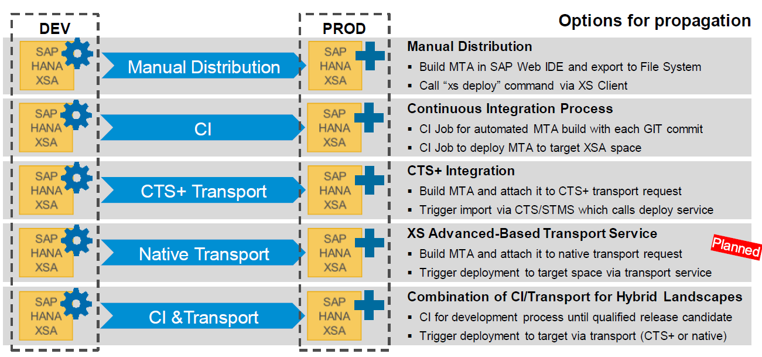

 | Manual Distribution | CI Continous Integration | CTS+ Transport | Native Transport | CI & Transport
Pro | Early project phase approach | Combines benefits of Devops and Agile Development | Unified approval, workflow , auditing | Planned  All steps automated, integrated with WebIDE  No ABAP systems needed | Benefits of CI for Agile development combined with  Auditing, approval features
Con | Manual | Complex setup due to several 3rd party componentrequirement | Not fully automated  Need ABAP based system |  | Complex setup limiation of CI apply

Considering the Pros and Cons of the available options the Use of CTS+ Transport option has been chosen for Application Lifecycle management at COLT. The below screen shot shows the steps involved in this option.

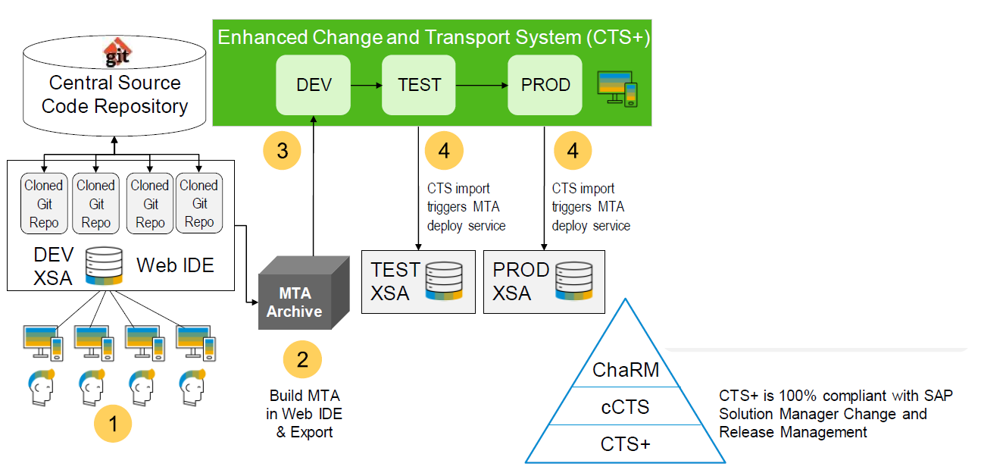

CTS+ Integration
Flow for CTS+
- Clone from Git, Develop in the SAP Web IDE just like the other options
- Build the MTAR in the SAP Web IDE and download the MTAR to your local machine.
- Switch to the CTS_ Transport Organizer Web IDE. Create a Transport Request and manually attach (upload) the MTAR into this request.
- Developer releases the transport in CTS+
- The transport request is then visible in the CTS+ import queue and follows whatever approval and workflow configured there (including ChaRM additional functionality).
- When the Import is trigger in CTS+, XSA Deploy service is called automatically behind the scenes.

Major Configurations Steps for ALM
- Create needed spaces on your SAP HANA XS advanced server(s)
2.Create users and assign user roles in the newly created spaces
3.Enable development space for development
4.Create HTTP(S) destinations in CTS+ system for all target spaces (test, production, …)
5.Configure the Transport Organizer Web UI (to be done for the first CTS+ integration only)
6.Configure the CTS+ application type for SAP HANA XS advanced (only needed once)
7.Create virtual representations for all SAP HANA XS advanced spaces in the CTS+ system
8.Configure the transport route(s) between the virtual systems

Please see: How To... Configure SAP HANA Extended Services – Advanced Model (XSA) for CTS

Security

Current Situation:
Power users - Access data directly from Subject DB tables
Reporting Users – Access restricted thru the Universe for different Application DB’s

Requirements for consideration:
- Cross Application Reporting Scenarios
- GDPR requirements – Data Masking
- Restrictive access to Subject application – HR
- No Access to tables
Options Discussed/Possible:
- Application Layer – Layer containing Custom views
- Subject DB layer - Collection of views relevant for the subject area 1:1
Approach:
Application layer - Application Container
Subject DB Layer – Subject DB container same for Sensitive information Like HR
App Layer - Custom view/s
ACCOUNTMU | CAMPAIGNSPROD1 | CORPREFDAT | INVENTORY | INVOICING | INVOLPARTY | LOCATION | PRODUCT | SERVASR | SERVIUSAGEPROD1

Options
Option 1 -
Reporting users – Access to Subject DB /Application DB objects - Access restricted at Reporting Application / Universe level on BO
Reporting user’s  BO Security Universe level | Universe | App Layer - Custom view/s - Selective views
Reporting user’s  BO Security Universe level | Universe | CAMPAIGNS | CORPREFDAT | INVOICING | INVOLPARTY
Reporting user’s  BO Security Universe level | Universe | App Layer - Custom view/s Selective views -Selective views
Reporting user’s  BO Security Universe level | Universe | LOCATION | PRODUCT | SERVASR | SERVIUSAGE
Reporting user’s  BO Security Universe level | Universe | App Layer - Custom view/s- Selective views
Reporting user’s  BO Security Universe level | Universe | SERVASR | SERVIUSAGE | INVOICING | INVOLPARTY

Power users- Access to Subject DB views + Selective views from Application layer where relevant – Managed by HANA Roles
Power user’s  Role Driven | Sales Role | App Layer - Custom view/s - Selective views
Power user’s  Role Driven | Sales Role | CAMPAIGNS | CORPREFDAT | INVOICING | INVOLPARTY
Power user’s  Role Driven | Service Role | App Layer - Custom view/s Selective views -Selective views
Power user’s  Role Driven | Service Role | LOCATION | PRODUCT | SERVASR | SERVIUSAGE
Power user’s  Role Driven | Sales/ Service Role | App Layer - Custom view/s- Selective views
Power user’s  Role Driven | Sales/ Service Role | SERVASR | SERVIUSAGE | INVOICING | INVOLPARTY

Option 2 (Recommended) –
Same approach can be used to restrict the HR like data by restricting access to Container
Reporting/ Power user’s  Role driven | Sales Role | App Layer - Custom view/s - Selective views
Reporting/ Power user’s  Role driven | Sales Role | CAMPAIGNS | CORPREFDAT | INVOICING | INVOLPARTY
Reporting/ Power user’s  Role driven | Service Role | App Layer - Custom view/s Selective views -Selective views
Reporting/ Power user’s  Role driven | Service Role | LOCATION | PRODUCT | SERVASR | SERVIUSAGE
Reporting/ Power user’s  Role driven | Sales/ Service Role | App Layer - Custom view/s- Selective views
Reporting/ Power user’s  Role driven | Sales/ Service Role | SERVASR | SERVIUSAGE | INVOICING | INVOLPARTY

High Level steps:
- Classification of User groups to be performed
- User to Object Level- Subject DB, Application Layer, Masking AUTH identified , Sensitive areas
- Roles created for scenarios identified in step 2
- Roles assigned to users

Additionally, Security for XSA will be designed as part of the project phase this will be tracked by a separate Security document.

To enable the developments and access to ETL and Visualization layers a set of users with specific roles will be created,

Testing
Below are some pointers for testing strategy, this should be used as a starting point.
Unit test:
As changes will be carried out at various levels testing at the below mentioned levels is recommended by SAP.
ETL- COLT/EY Team
As the existing ETL jobs will be pointed to HANA this has to be tested extensively at an early stage to identify any discrepancies, this can be achieved by execution of scripts to detects errors and used to identify ETL mapping issues as well as table structure inconsistencies.

Data Comparison- COLT/ EY Team
Data comparison between Netezza and HANA needs to be performed, due to the limitation on the Hardware for Sandbox this activity should be performed on a selective set of data.
Option 1 -
This can be achieved with the help of Remote connection to the Netezza system and retrieving the Netezza table as remote table in HANA union with HANA table with a minus statement to detect differences. Although the initial effort to create the scripts will be higher they can be reused in all the other environments after deployment to each system. Alternatively, the same can be achieved using a graphical view and the views can be deployed into the landscape.
Option 2 –
Performed at the reporting level.
A fresh copy of Netezza prior to the project will help in this case as the data from the source can be compared with the data in HANA after repointing the connections.
The data comparison activity will also help to identify data type mismatches.

HANA Modelling – SAP
HANA modelling unit test will comprise of validating HANA table data against the view/ NDSO output in direct scenarios, for custom scenarios the output of the target structure will be compared with the underlying views.

Integration test:
This test should be performed by Business teams at a reporting level by comparing data in the Netezza system against the data in HANA system in the QA environment.

ETL loads should be validated for performance and structural inconsistencies, this activity can be performed by COLT IT team.

Currently out of scope but should be considered for Phase 2.

- ETL redesign
- Universe replacement by HANA views
- HANA Model redesign
- App developments
- Real time reporting
- Continuous Integration

Appendix –

- The attached file contains the split of each of the different levels of tables i.e. L1, L2,l3, Snapshot, Summary.
- This detail is used to derive the development efforts and will be considered as a tracker.
- The information contained in the file is of 07th December 2018 and will form base for the effort estimation and delivery.
- Additional objects are expected to be added to the list but should be tracked separately.

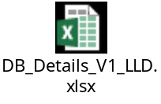

References – To be updated

- 2465027 - Deprecation of SAP HANA extended application services, classic model and SAP HANA Repository
- 2555629 - SAP HANA 2.0 Dynamic Tiering – Hypervisor and Cloud Support
- https://www.sap.com/documents/2017/01/f008600c-a57c-0010-82c7-eda71af511fa.html

